**PART -2 Windows Forms**

**Aim 6: Create a windows form which implements Menus (File, Color) and a Text Box. File menu item has 4 options Font, Open, Save, Print (Print Preview and Print), Exit. Color menu opens a Color Dialog box. Clicking on the colors sets the background of the form with respective color. Open menu item opens a file, reads the contents and displays in the TextBox while Save menu items saves the content of Text Box in to a file.**

**Also provide a Context Menu of your choice.**

**Program**:

using System;

using System.Collections.Generic;

using System.ComponentModel;

using System.Data;

using System.Drawing;

using System.Linq;

using System.Text;

using System.Windows.Forms;

using System.IO;

namespace WindowsFormsApplication3_6

{

public partial class Form1 : Form

{

public Form1()

{

InitializeComponent();

}

private void colorToolStripMenuItem_Click(object sender, EventArgs e)

{

ColorDialog clg = new ColorDialog();

if (clg.ShowDialog() == DialogResult.OK)

{

textBox1.BackColor = clg.Color;

}

}

private void fontToolStripMenuItem_Click(object sender, EventArgs e)

{

FontDialog fd = new FontDialog();

if (fd.ShowDialog() == DialogResult.OK)

{

textBox1.Font = fd.Font;

}

}

private void openToolStripMenuItem_Click(object sender, EventArgs e)

{

OpenFileDialog ofd = new OpenFileDialog();

ofd.Title = "open file";

ofd.InitialDirectory = @"C:\Users\admin\Desktop:\";

ofd.Filter="Text files(*.txt)|*.txt";

if (ofd.ShowDialog() == DialogResult.OK)

{

textBox1.Text = File.ReadAllText(ofd.FileName);

}

}

private void saveToolStripMenuItem_Click(object sender, EventArgs e)

{

string path = @"C:\Users\admin\Desktop\p2.txt";

File.WriteAllText(path, textBox1.Text);

MessageBox.Show("FILE SAVED SUCCESSFULLY");

}

private void printToolStripMenuItem1_Click(object sender, EventArgs e)

{

PrintDialog pdlg = new PrintDialog();

pdlg.Document = printDocument1;

if (pdlg.ShowDialog() == DialogResult.OK)

{

printDocument1.Print();

}

}

private void printPreviewToolStripMenuItem_Click(object sender, EventArgs e)

{

PrintPreviewDialog ppdlg = new PrintPreviewDialog();

ppdlg.Document = printDocument1;

ppdlg.ShowDialog();

}

private void exitToolStripMenuItem_Click(object sender, EventArgs e)

{

Application.Exit();

}

private void printDocument1_PrintPage(object sender, System.Drawing.Printing.PrintPageEventArgs e)

{

Graphics g;

g=this.CreateGraphics();

g.DrawString(textBox1.Text, textBox1.Font, new SolidBrush(textBox1.ForeColor), 10, 10);

}

private void cutToolStripMenuItem_Click(object sender, EventArgs e)

{

textBox1.Cut();

}

private void copyToolStripMenuItem_Click(object sender, EventArgs e)

{

textBox1.Copy();

}

private void pasteToolStripMenuItem_Click(object sender, EventArgs e)

{

textBox1.Paste();

}

}

}

**OUTPUT**:

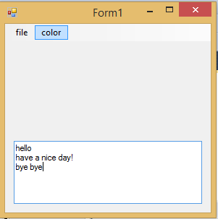 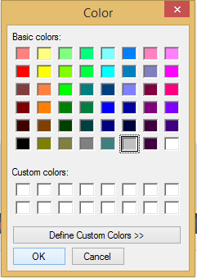

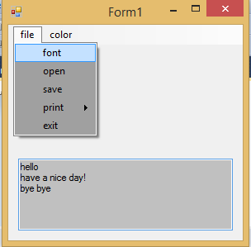 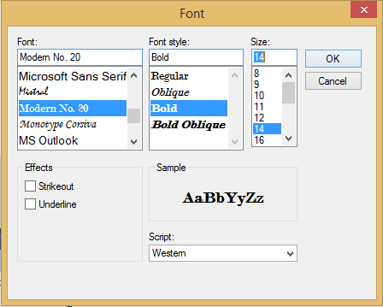

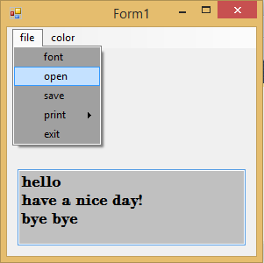 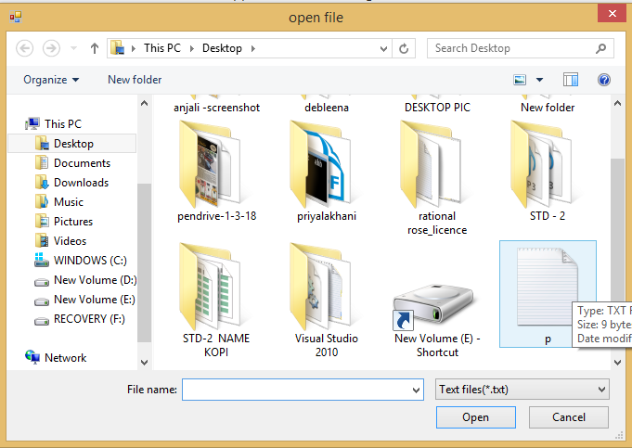

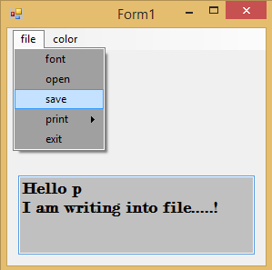 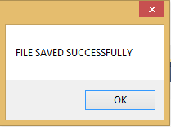

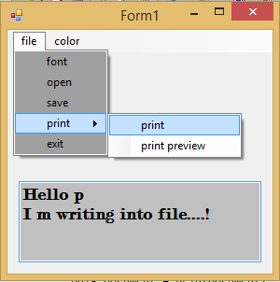 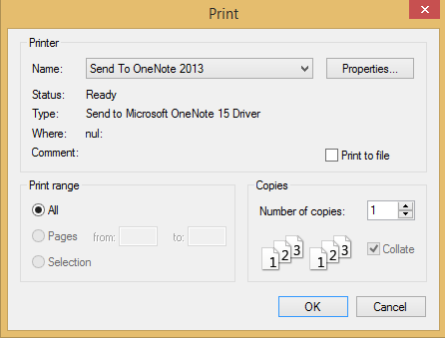

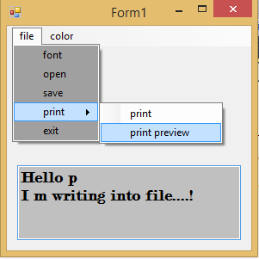 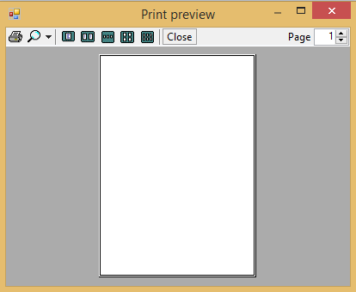

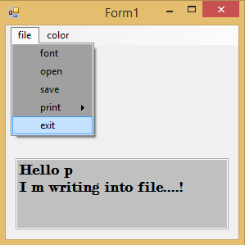

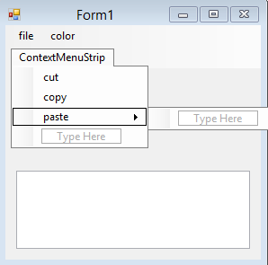 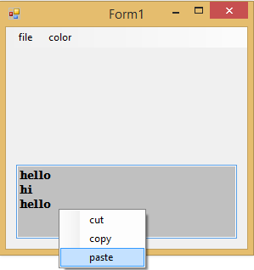

**Aim 7: Implement an MDI form with Menu item “Add”, clicking on Add generates a new child form (blank). And Menu item “Child Forms” which contains sub menu for implementing Error Provider, Tool tip, Panel and Group Box controls each on a separate form.**

**Program**:

using System;

using System.Collections.Generic;

using System.ComponentModel;

using System.Data;

using System.Drawing;

using System.Linq;

using System.Text;

using System.Windows.Forms;

namespace WindowsFormsApplication3_2_7

{

public partial class Form1 : Form

{

Form2 f2;

Form3 f3;

Form4 f4;

Form5 f5;

Form6 f6;

public Form1()

{

InitializeComponent();

}

private void addToolStripMenuItem_Click(object sender, EventArgs e)

{

if (f2 == null)

{

f2 = new Form2();

f2.MdiParent = this;

f2.Show();

}

}

private void errorProviderToolStripMenuItem_Click(object sender, EventArgs e)

{

if (f3 == null)

{

f3 = new Form3();

f3.MdiParent = this;

f3.Show();

}

}

private void toolTipToolStripMenuItem_Click(object sender, EventArgs e)

{

if (f4 == null)

{

f4 = new Form4();

f4.MdiParent = this;

f4.Show();

}

}

private void panelToolStripMenuItem_Click(object sender, EventArgs e)

{

if (f5 == null)

{

f5 = new Form5();

f5.MdiParent = this;

f5.Show();

}

}

private void groupBoxToolStripMenuItem_Click(object sender, EventArgs e)

{

if (f6 == null)

{

f6 = new Form6();

f6.MdiParent = this;

f6.Show();

}

}

}

}

Form3.cs

using System;

using System.Collections.Generic;

using System.ComponentModel;

using System.Data;

using System.Drawing;

using System.Linq;

using System.Text;

using System.Windows.Forms;

namespace WindowsFormsApplication3_2_7

{

public partial class Form3 : Form

{

public Form3()

{

InitializeComponent();

}

private void Form3_Load(object sender, EventArgs e)

{

}

private void textBox1_TextChanged(object sender, EventArgs e)

{

string str = textBox1.Text;

foreach (char a in str)

{

if (char.IsDigit(a))

{

errorProvider1.SetError(textBox1, "please enter name");

}

else

{

errorProvider1.Clear();

}

}

}

private void textBox2_TextChanged(object sender, EventArgs e)

{

string str = textBox2.Text;

foreach(char a in str)

{

if(char.IsLetter(a))

{

errorProvider1.SetError(textBox2,"Invalid Number!Letters present!");

}

else

{

errorProvider1.Clear();

}

}

}

}

}

Form4.cs

using System;

using System.Collections.Generic;

using System.ComponentModel;

using System.Data;

using System.Drawing;

using System.Linq;

using System.Text;

using System.Windows.Forms;

namespace WindowsFormsApplication3_2_7

{

public partial class Form4 : Form

{

public Form4()

{

InitializeComponent();

}

private void Form4_Load(object sender, EventArgs e)

{

toolTip1.ShowAlways = true;

toolTip1.SetToolTip(button1, "Click me to execute.");

}

private void button1_Click(object sender, EventArgs e)

{

}

}

}

Form5.cs

using System;

using System.Collections.Generic;

using System.ComponentModel;

using System.Data;

using System.Drawing;

using System.Linq;

using System.Text;

using System.Windows.Forms;

namespace WindowsFormsApplication3_2_7

{

public partial class Form5 : Form

{

public Form5()

{

InitializeComponent();

}

private void Form5_Load(object sender, EventArgs e)

{

}

}

}

Form6.cs

using System;

using System.Collections.Generic;

using System.ComponentModel;

using System.Data;

using System.Drawing;

using System.Linq;

using System.Text;

using System.Windows.Forms;

namespace WindowsFormsApplication3_2_7

{

public partial class Form6 : Form

{

public Form6()

{

InitializeComponent();

}

private void Form6_Load(object sender, EventArgs e)

{

}

}

}

**OUTPUT**:

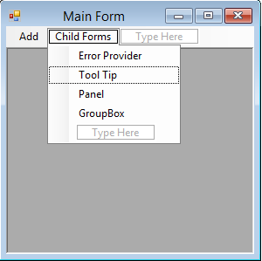 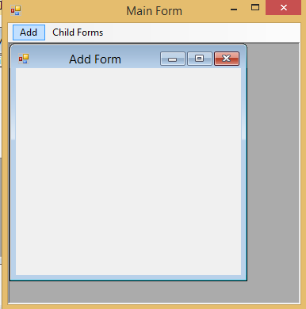

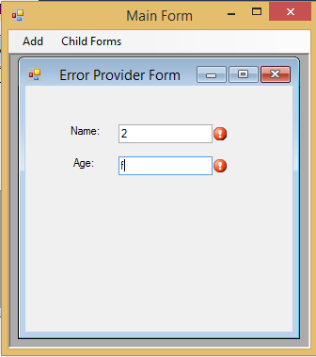 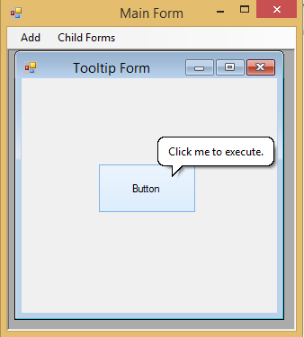

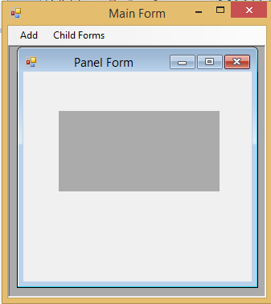 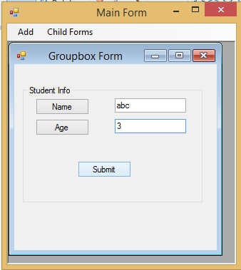

**Aim 8: Create a custom control for calculating Simple Interest and Compound Interest.**

**Program**:

UserControl1.cs

using System;

using System.Collections.Generic;

using System.ComponentModel;

using System.Drawing;

using System.Data;

using System.Linq;

using System.Text;

using System.Windows.Forms;

namespace WindowsFormsControlLibrary1

{

public partial class UserControl1 : UserControl

{

public UserControl1()

{

InitializeComponent();

}

private void button1_Click(object sender, EventArgs e)

{

double si, p, r, t;

p = Convert.ToDouble(textBox1.Text);

r = Convert.ToDouble(textBox2.Text);

t = Convert.ToDouble(textBox3.Text);

si = (p * r * t) / 100;

label5.Text = si.ToString();

}

private void button2_Click(object sender, EventArgs e)

{

double ci, p, r, t, n, a , b , c;

p = Convert.ToDouble(textBox1.Text);

r = Convert.ToDouble(textBox2.Text);

t = Convert.ToDouble(textBox3.Text);

n = Convert.ToDouble(textBox4.Text);

a = (n + r) / n;

b = n * t;

c = Math.Pow(a, b);

ci = p * c;

label6.Text = ci.ToString();

}

}

}

Form1.cs

using System;

using System.Collections.Generic;

using System.ComponentModel;

using System.Data;

using System.Drawing;

using System.Linq;

using System.Text;

using System.Windows.Forms;

namespace WindowsFormsControlLibrary1

{

public partial class Form1 : Form

{

public Form1()

{

InitializeComponent();

}

private void Form1_Load(object sender, EventArgs e)

{

}

}

}

**OUTPUT**:

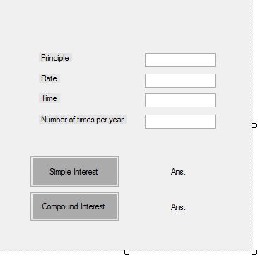

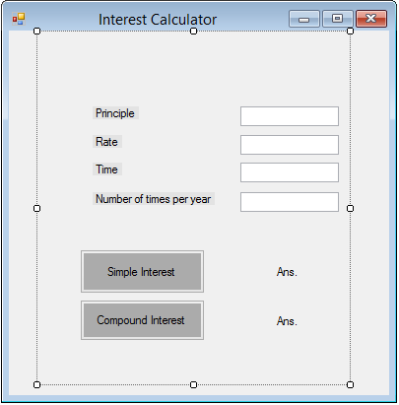

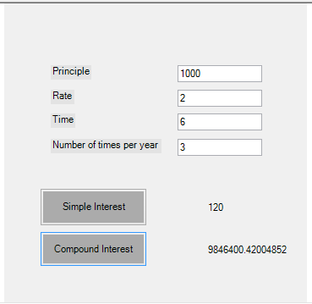

**PART -3 ADO.NET**

**Aim 1:** **Implement the Windows Application.**

**Program**:

using System;

using System.Collections.Generic;

using System.ComponentModel;

using System.Data;

using System.Data.SqlClient;

using System.Drawing;

using System.Linq;

using System.Text;

using System.Windows.Forms;

namespace WindowsFormsApplication6_ado.net_1

{

public partial class Form1 : Form

{

SqlConnection con;

SqlDataAdapter adp;

DataSet ds;

SqlDataReader dr;

SqlCommand cmd;

public Form1()

{

InitializeComponent();

}

private void Form1_Load(object sender, EventArgs e)

{

con = new SqlConnection();

con.ConnectionString = @"Data Source=.\SQLEXPRESS;AttachDbFilename=C:\Users\Administrator\Documents\150420107029.mdf;Integrated Security=True;Connect Timeout=30;User Instance=True";

if (con.State != ConnectionState.Open)

{

con.Open();

MessageBox.Show("connection establish succeessfully!");

}

BindCombobox();

BindGrid();

}

public void BindCombobox()

{

adp=new SqlDataAdapter("select * from Department",con);

ds=new DataSet();

adp.Fill(ds);

if(ds.Tables[0].Rows.Count==0)

{

MessageBox.Show("No Records are present");

}

else

{

cmbDept.DataSource=ds.Tables[0];

cmbDept.ValueMember=ds.Tables[0].Columns["Department_Code"].ToString();

cmbDept.DisplayMember=ds.Tables[0].Columns["Department_Name"].ToString();

}

}

public void BindGrid()

{

adp.Dispose();

ds.Dispose();

adp = new SqlDataAdapter("select * from Employee", con);

ds = new DataSet();

adp.Fill(ds);

this.dataGridView1.DataSource = ds.Tables[0];

}

private void Cancel_Click(object sender, EventArgs e)

{

this.Close();

}

private void checkBox1_CheckedChanged(object sender, EventArgs e)

{

if (checkBox1.Checked == true)

{

checkBox1.Text = "Active";

}

else

{

checkBox1.Text = "InActive";

}

}

private void Save_Click(object sender, EventArgs e)

{

int gender, status, cnt;

String hobbies = " ";

if (rb_male.Checked == true && rb_female.Checked == false)

{

gender = 1;

}

else

{

gender = 2;

}

if (checkBox1.Checked == true)

{

status = 0;

}

else

{

status = 1;

}

for (int i = 0; i <= checkedListBox1.CheckedItems.Count - 1; i++)

{

if (i == 0)

{

hobbies = checkedListBox1.CheckedItems[i].ToString();

}

else

{

hobbies += "," + checkedListBox1.CheckedItems[i].ToString();

}

}

if (this.textBox1.Text != "")

{

cmd = new SqlCommand();

//string qry = "insert into Employee(Employee_Code,Name,Department,Address,Gender,Status,Hobbies) values (" +

// "'" + textBox1.Text + "','" + textBox2.Text + "','" + cmbDept.SelectedValue + "','" + textBox3.Text + "'," + gender + "," + status + ",'" + hobbies + "')";

// MessageBox.Show(qry);

cmd.CommandText = "insert into Employee(Employee_Code,Name,Department,Address,Gender,Status,Hobbies) values (" +

"'" + textBox1.Text + "','" + textBox2.Text + "','" + cmbDept.SelectedValue + "','" + textBox3.Text + "'," + gender + "," + status + ",'" + hobbies + "')";

cmd.Connection = con;

cmd.CommandType = CommandType.Text;

cnt = cmd.ExecuteNonQuery();

if (cnt > 0)

{

MessageBox.Show("Record inserted successfully", "Employee", MessageBoxButtons.OK);

BindGrid();

ResetForm();

}

else

{

MessageBox.Show("error", "Employee", MessageBoxButtons.OK);

}

}

}

public void ResetForm()

{

textBox1.Text = "";

textBox2.Text = "";

textBox3.Text = "";

cmbDept.SelectedIndex = 0;

checkBox1.Checked = false;

rb_female.Checked = false;

rb_male.Checked = false;

for (int i = 0; i < checkedListBox1.Items.Count; i++)

{

checkedListBox1.SetItemCheckState(i, CheckState.Unchecked);

}

}

private void Search_Click(object sender, EventArgs e)

{

string str, empcode = "";

empcode = textBox1.Text;

ResetForm();

str = "select * from Employee where Employee_Code='" + empcode + "'";

cmd = new SqlCommand();

cmd.Connection = con;

cmd.CommandType = CommandType.Text;

cmd.CommandText = str;

dr = cmd.ExecuteReader();

if (dr.Read())

{

textBox1.Text = Convert.ToString(dr.GetValue(0));

textBox2.Text = Convert.ToString(dr.GetValue(1));

cmbDept.SelectedValue = Convert.ToString(dr.GetValue(2));

textBox3.Text = Convert.ToString(dr.GetValue(5));

if (Convert.ToUInt16(dr.GetValue(3)) == 1)

{

rb_male.Checked = true;

}

else

{

rb_female.Checked = true;

}

if (Convert.ToInt16(dr.GetValue(4)) == 1)

{

checkBox1.Checked = true;

}

else

{

checkBox1.Checked = false;

}

string temp = dr.GetValue(6).ToString();

string[] arr = temp.Split(',');

for (int i = 0; i < checkedListBox1.Items.Count; i++)

{

for (int j = 0; j <= arr.Length - 1; j++)

{

if (arr[j] == checkedListBox1.Items[i].ToString())

{

checkedListBox1.SetItemCheckState(i, CheckState.Checked);

}

}

}

}

else

{

MessageBox.Show("employee does not exist", "Employee", MessageBoxButtons.OK);

}

dr.Close();

}

private void Update_Click(object sender, EventArgs e)

{

cmd = new SqlCommand();

cmd.Connection = con;

string empcode = "";

empcode = textBox1.Text;

int gender,status;

string hobbies = "";

if (rb_male.Checked == true && rb_female.Checked == false)

{

gender = 1;

}

else

{

gender = 2;

}

if (checkBox1.Checked == true)

{

status = 0;

}

else

{

status = 1;

}

for (int i = 0; i <= checkedListBox1.CheckedItems.Count - 1; i++)

{

if (i == 0)

{

hobbies = checkedListBox1.CheckedItems[i].ToString();

}

else

{

hobbies += "," + checkedListBox1.CheckedItems[i].ToString();

}

}

cmd.CommandText="update Employee SET Name='"+textBox2.Text+"',Department='"+cmbDept.SelectedValue.ToString()+"',Gender="+gender+",Status="+status+",Address='"+textBox3.Text+"',Hobbies='"+hobbies+"' where Employee_Code='" + empcode + "'";

cmd.CommandType = CommandType.Text;

DialogResult dlr = new DialogResult();

dlr = MessageBox.Show("Are you sure you want to update record?", "Employee", MessageBoxButtons.YesNo);

if (dlr == DialogResult.Yes)

{

int count = cmd.ExecuteNonQuery();

if (count > 0)

{

MessageBox.Show("record updated successfully", "Employee", MessageBoxButtons.OK);

ResetForm();

BindGrid();

}

}

}

private void Delete_Click(object sender, EventArgs e)

{

string empcode = "";

empcode = textBox1.Text;

cmd = new SqlCommand();

cmd.Connection = con;

cmd.CommandText = "delete from EMPLOYEE where Employee_Code='" + empcode + "'";

cmd.CommandType = CommandType.Text;

DialogResult dlr = new DialogResult();

dlr =MessageBox.Show("Are you sure you want to delete record?", "Employee", MessageBoxButtons.YesNo);

if (dlr == DialogResult.Yes)

{

int count = cmd.ExecuteNonQuery();

if (count > 0)

{

MessageBox.Show("record deleted successfully", "Employee", MessageBoxButtons.OK);

ResetForm();

BindGrid();

}

}

}

}

}